**Ways to Regulate Pressure:**

* Regulate pressure using negative feedback from only the spirometer (tidal volume). Pressure adjusted to get correct tidal volume.
* Regulate pressure using input from a combination of pressure sensors and spirometer, so both pressures and tidal volume are in the acceptable range.

**Design Ideas/Implementation:**

* <https://physics.stackexchange.com/questions/95620/how-does-pressure-of-a-fluid-change-with-area-according-to-the-continuity-equat>
  + Decrease cross-sectional area → pressure decreases
* Pressure Range Needed:
  + Normal patients: Normal lung compliance is around 100 ml/cmH20. This means that in a normal lung the administration of 500 ml of air via positive pressure ventilation will increase the alveolar pressure by 5 cm H2O. Conversely, the administration of a positive pressure of 5 cm H2O will generate an increase in lung volume of 500 mL
* DIY Stepper Motor
* DIY Servo Motor

<https://www.instructables.com/id/Arduino-Servo-Motors/>

<https://www.tutorialspoint.com/arduino/arduino_servo_motor.htm>

* Solenoid Valve + Microcontroller - <https://hackaday.io/project/148274-electronic-pressure-regulator>

<https://www.bc-robotics.com/tutorials/controlling-a-solenoid-valve-with-arduino/>

* Using a servo motor + force sensor (?) <https://cdn.sparkfun.com/datasheets/Sensors/ForceFlex/2010-10-26-DataSheet-FSR400-Layout2.pdf>
* [FLUID FLOW BASICS OF THROTTLING VALVES](https://www.controlglobal.com/assets/Media/MediaManager/RefBook_Cashco_Fluid.pdf)
* [fundamentals-valves-types](https://instrumentationtools.com/fundamentals-valves-types/)

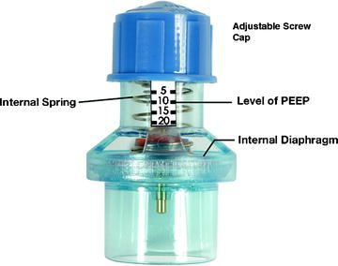

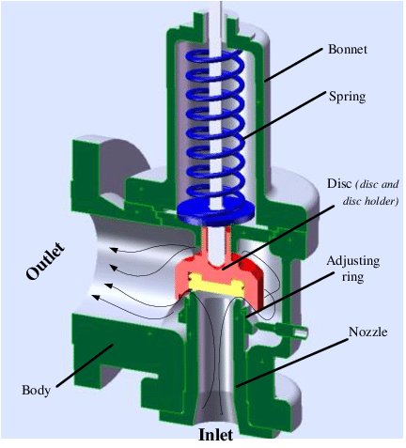

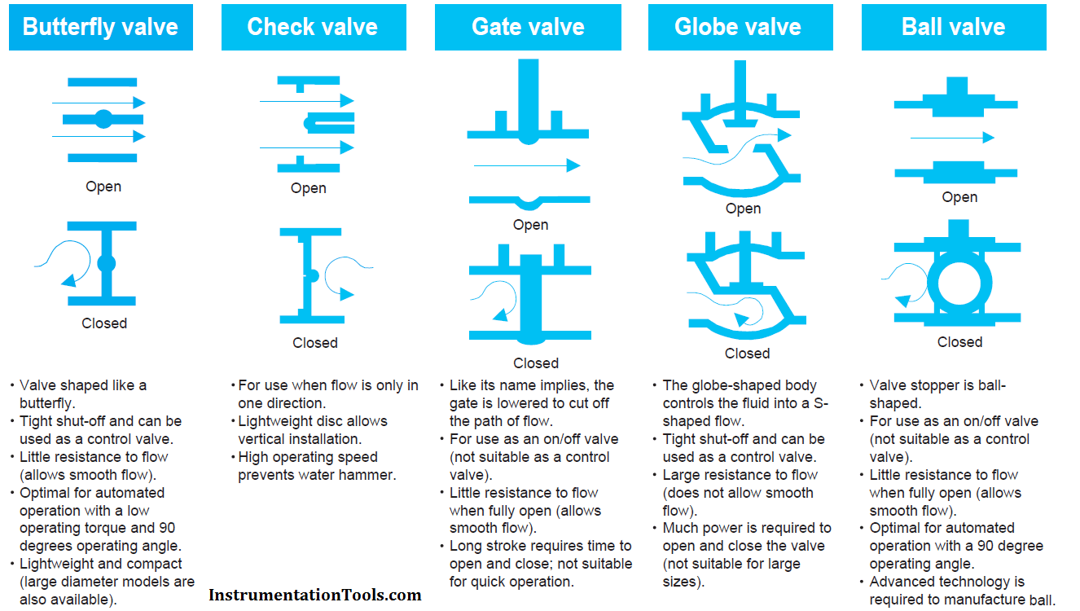

**Testing:**

**Materials:**

* From the [video](https://www.youtube.com/watch?v=2vAoOYF3m8U) from last time:
  + 3D Parts: <https://www.thingiverse.com/thing:3170748>
  + 3D Parts: <https://www.myminifactory.com/object/3d-print-77542>
  + Servos: <https://www.amazon.com/FEETECH-FS90R-Pack-Continuous-himalayanelixir/dp/B07824TSXB/ref=psdc_2234131011_t1_B074BFQC3Q>
  + Epoxy: <https://www.amazon.com/gp/product/B005UYVIXO/ref=as_li_tl?ie=UTF8&tag=potentprintab-20&camp=1789&creative=9325&linkCode=as2&creativeASIN=B005UYVIXO&linkId=4604264d0434a096933684226449351d>
  + Arduino Uno
  + Adafruit Motor/Stepper/Servo Shield (<https://www.amazon.com/gp/product/B00PUTH3B0/ref=as_li_tl?ie=UTF8&tag=potentprintab-20&camp=1789&creative=9325&linkCode=as2&creativeASIN=B00PUTH3B0&linkId=68c63b4bb33a5eaaa4cf3d79c7247bc4>)

**3D Printing Sources:**

* List of Sources: <https://www.makepartsfast.com/outsourcing-options-for-3d-printing/>
* Pros and Cons of Different Sources: <https://www.howtogeek.com/303866/how-to-3d-print-anything-even-if-you-dont-own-a-3d-printer/>
  + Shapeways: This is good if you need a professional’s opinion and has people that can help, but it may be more of a place to shop for already designed 3D parts. It is possible to print your own designs though.
  + 3D Hubs: You can shop around to find the best printer source, but there’s not much you can do for quality control (there’s a money-back guarantee though that addresses this). The best pro is its speedy delivery time, which would be good for us.
  + Sculpteo: You can order your models in bulk, which might be helpful in the future.
* From a previous meeting, there was also a Google Sheets with many people volunteering their 3D printers to be used. I couldn’t find the link, but this might be nice, given that we are all working at different places and could then all of us could work on it.